**Practical No : 04**

Q1. Write a JAX-WS web service to perform the following operations. Define a Servlet / JSP that consumes the web service.

Step 1: Create a new project. Click on web application 🡪 Name of project 🡪 Next 🡪 Finish.

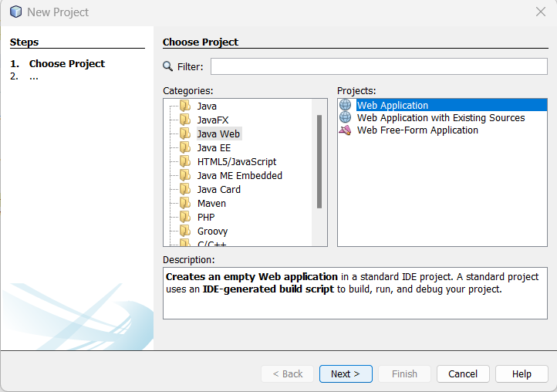

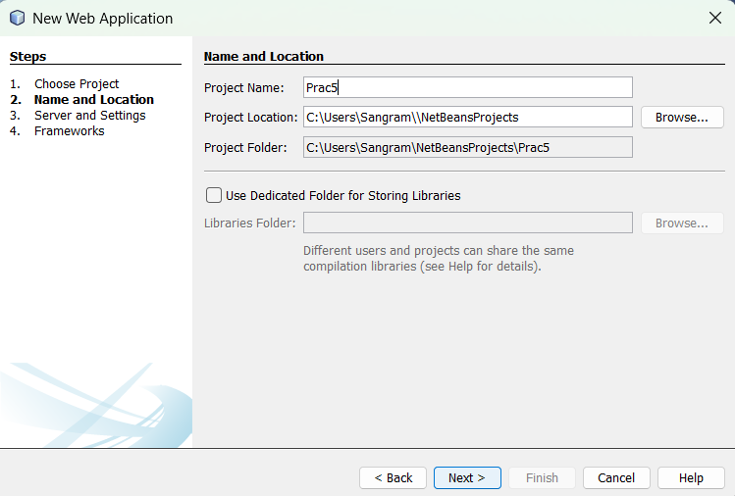

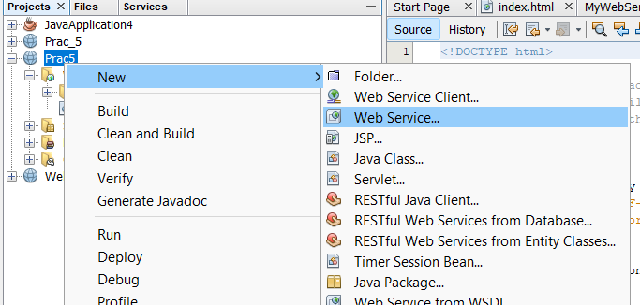Step 2: Once your project is successfully created. Expand your project, right click on project. Select New 🡪 Web Service. Enter the name of new Web Service as operation & package name as com.kk. Click on Finish options.

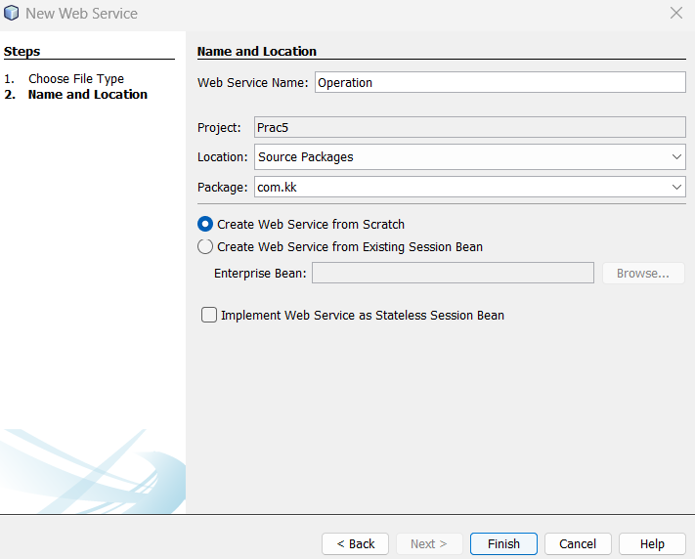

Step 3: Once your web service Created. Remove the selected part from Operation.java

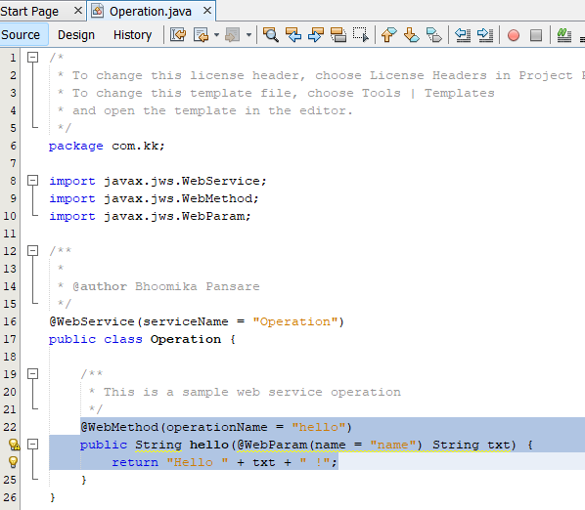

Step 4: Now go to the project palate. Expand your project, Go to the web services 🡪 Operation. Right click on Web service, select Test Web Service.

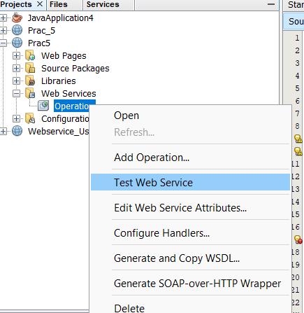

Step 5: Add Operations. The first operation is Addition.

Operation name is Add. The return type will be integer. Add some parameter.

Now here I am taking two parameters.

Parameter name is a & type will be integer.

Parameter name is b & type will be integer. After that, click on OK button.

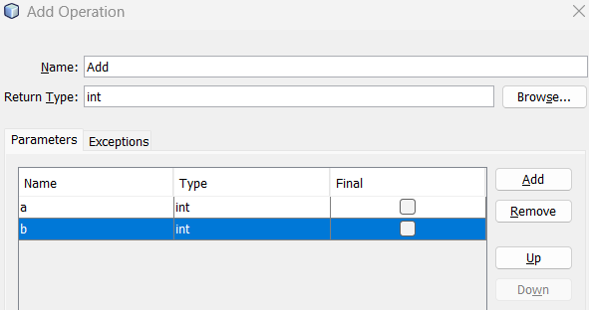

Step 6: Now the declaration of variable.

Int c = a+b;

Return c;

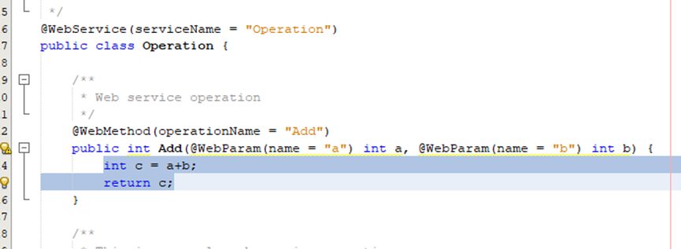

Step 7: Now repeat, the Step 4 & 5 for creation of Subtraction, multiplication & division Operation.

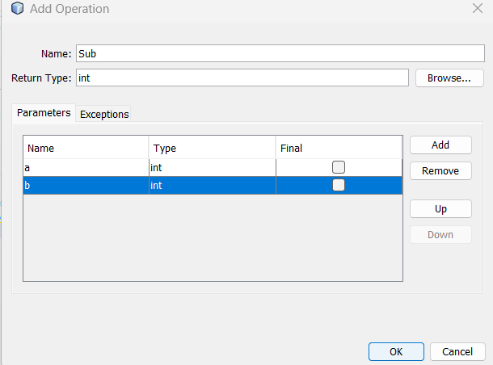

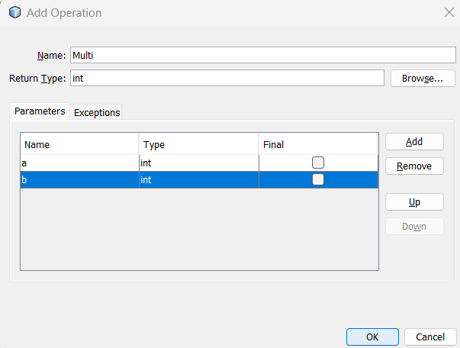

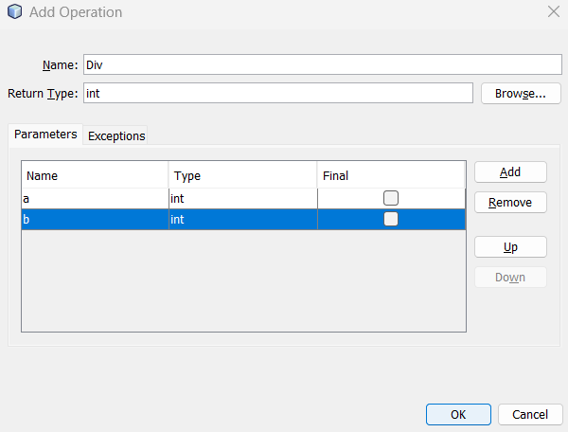

Step 8: Now, write the following code for subtraction, multiplication & division method.

**Subtraction method:**

int c = a-b;

return c;

**Multiplication method:**

int c = a*b;

return c;

**Division method:**

int c = a/b;

return c;

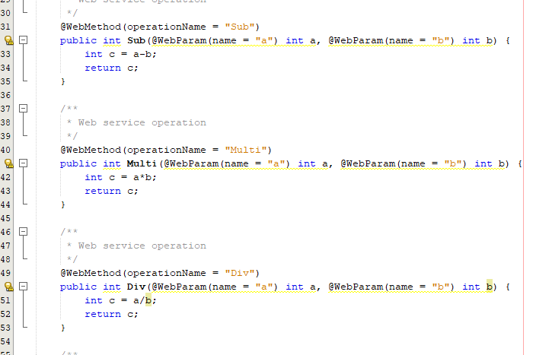

Step 9: Now test your web service.

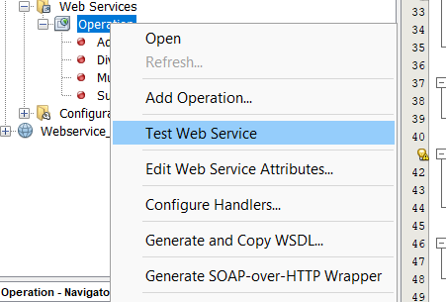

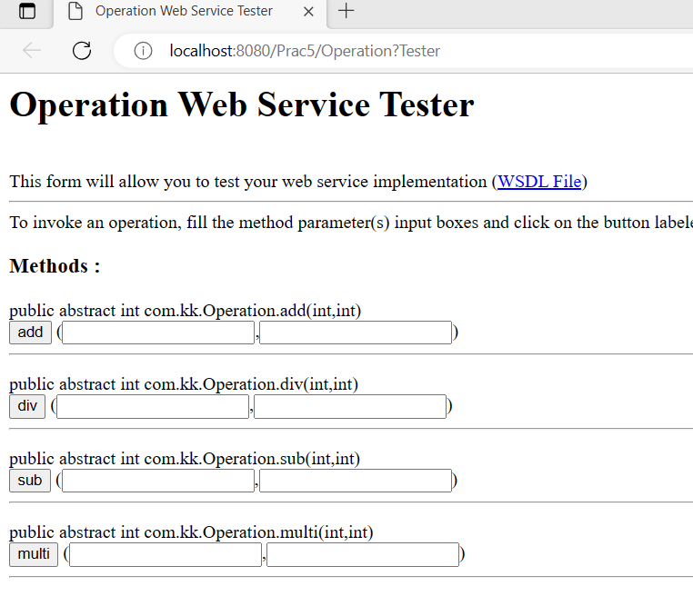

Step 10: Now right click on project. Select New 🡪 JSP page. Give the file name & click on Finish.

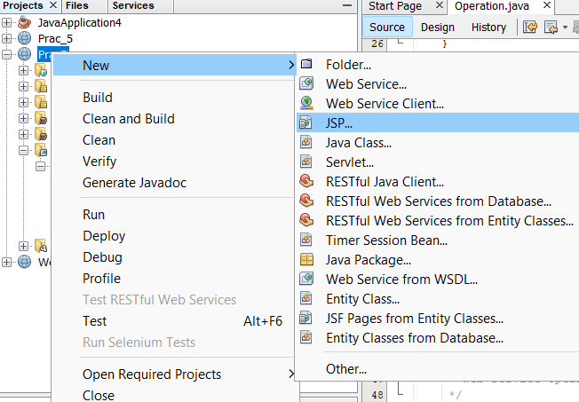

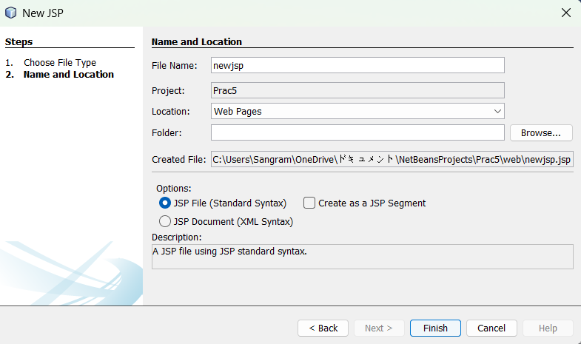

Step 11: Write the following code in JSP page.

<%

com.kk.Operation a1=new com.kk.Operation();

int d=a1.addition(3, 6);

int e=a1.subtraction(76, 45);

int f=a1.multiplication(3, 5);

int g=a1.division(4, 2);

out.println("Sangram Ghorpade 248624<br>");

out.println("Add:"+d);

out.println("<br>Sub:"+e);

out.println("<br>Mul:"+f);

out.println("<br>Div:"+g);

%>

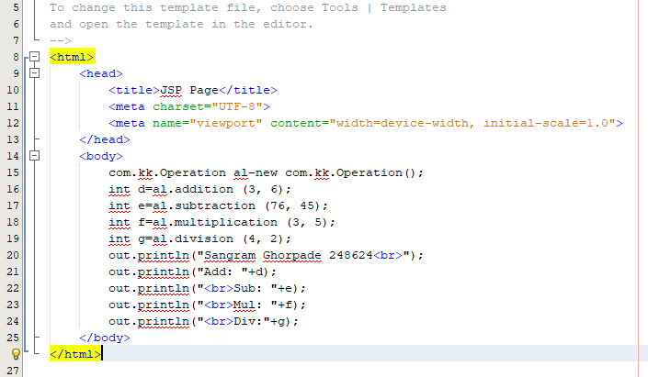

Step 12: Now right click on JSP page page. Click on Run file.

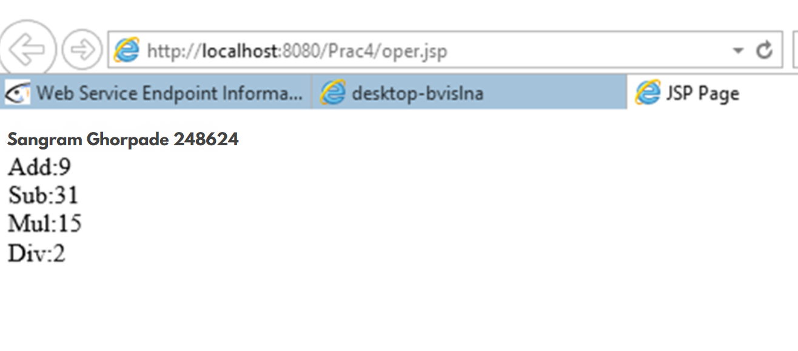

Q2. Write a JAX-WS web service server & client to perform the following operations. Define a servlet/ JSP that consumes the web service.

Step 1: Create a new project. New project 🡪 Java Web 🡪 Web Application.

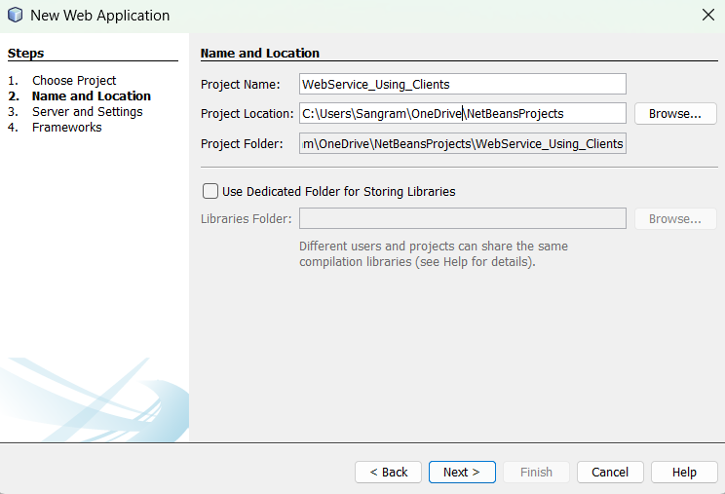

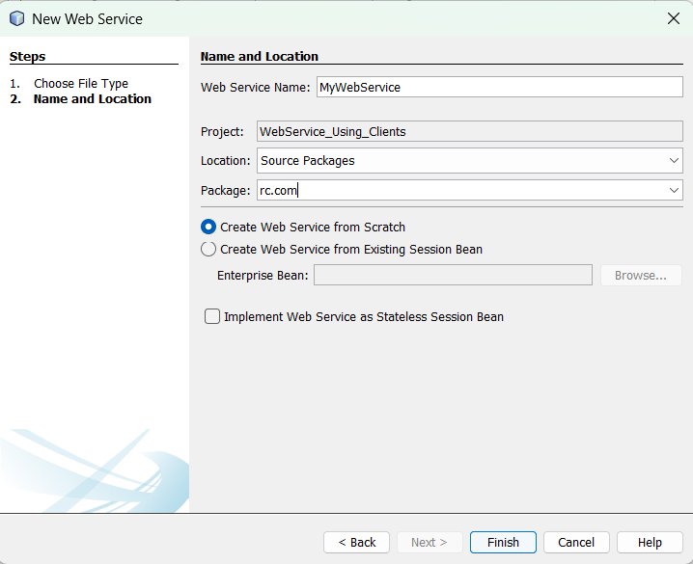

Step 2: Right click on newly created project. Create a new web service. The service name is MyWebServices & package name is rc.com.

Step 3: Remove the selected content from MyWebService.java

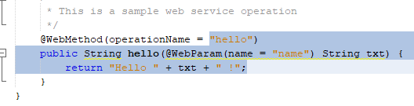

Step 4: Write the following code in deleted content.

@WebMethod (operationName = "Square")

public double square (double val) {

return val*val;

}

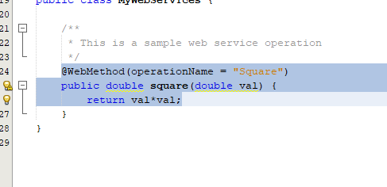

Step 5: Now go to the palate. Right click on index.html in project. Click on run file.

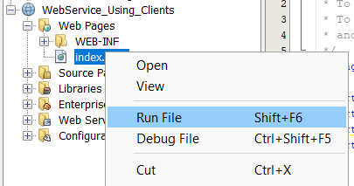

The following window will open after run your index.html file.

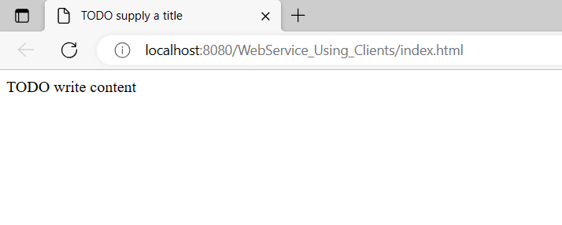

Step 6: Remove the selected part from link.

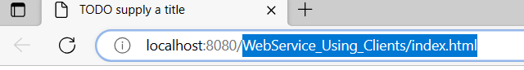

Now, the below window will open.

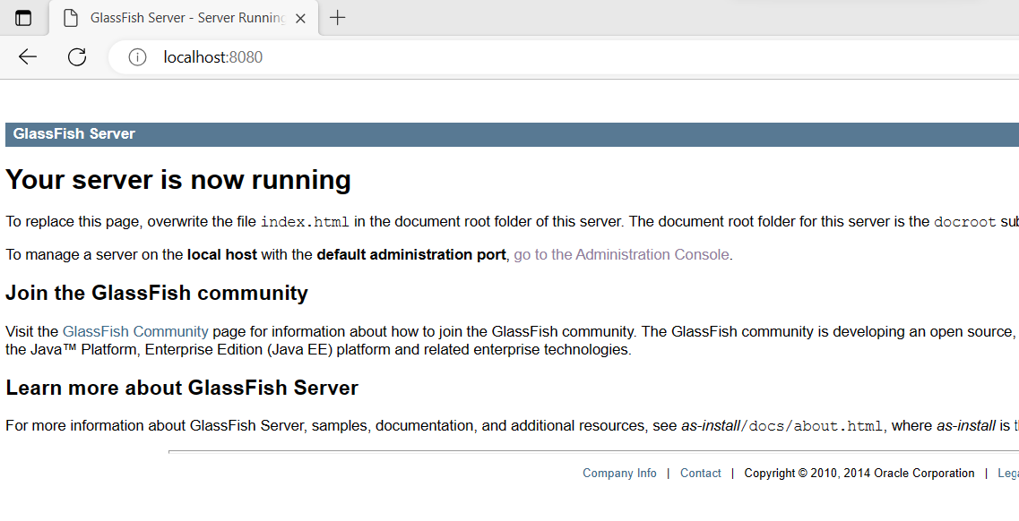

Step 7: Click on go to the administration console.



The following window will open.

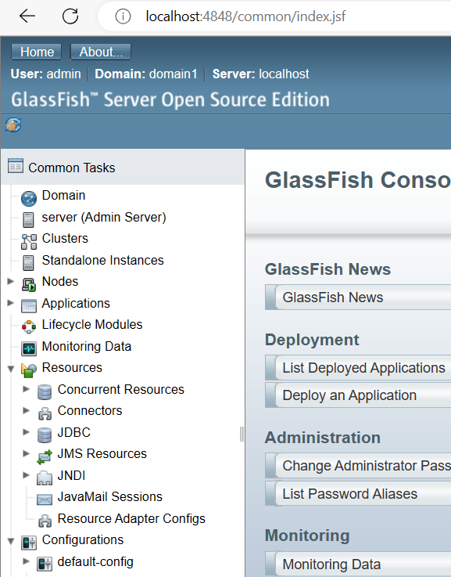

Step 8: In left side panel, expand the Application task. Click on your project.

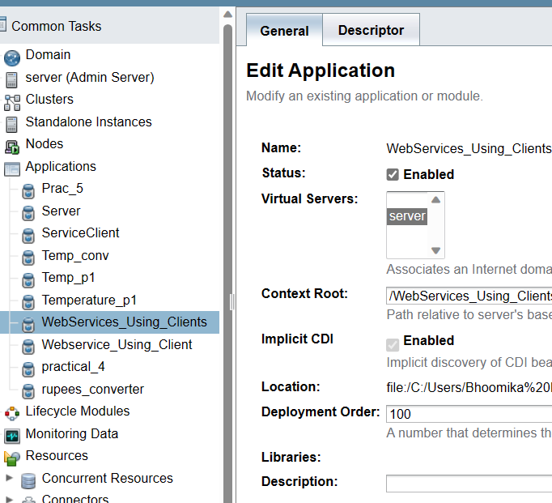

Step 9: Go to the general. Scroll down the page, there is one table which name is Modules & Components. In action column, click on View Endpoint.

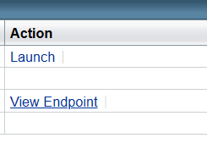

Step 10: Click on /WebServices_Using_Clients/MyWebServices?wsdl link.

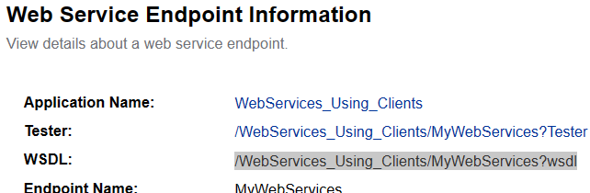

Step 11: When you click on link. The View WSDL window will open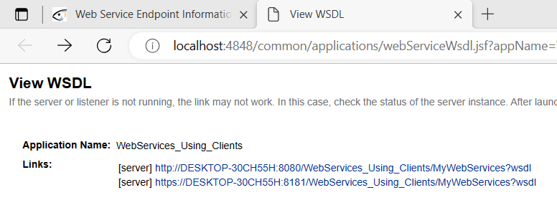

Step 12: Click on first link which will provide the access of server.

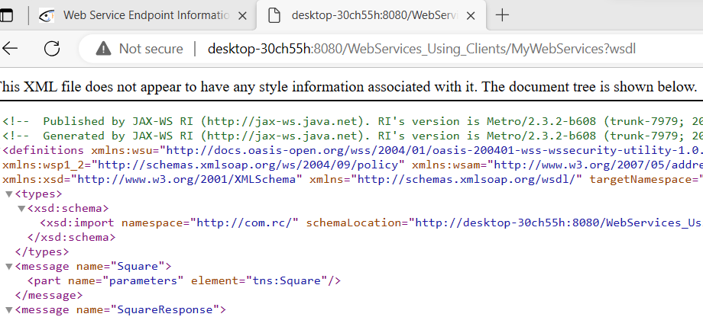

Step 13: Copy the link from search engine to notepad.

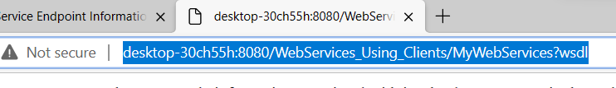

Now minimize the Microsoft edge window.

Step 13: Create a new Java project.

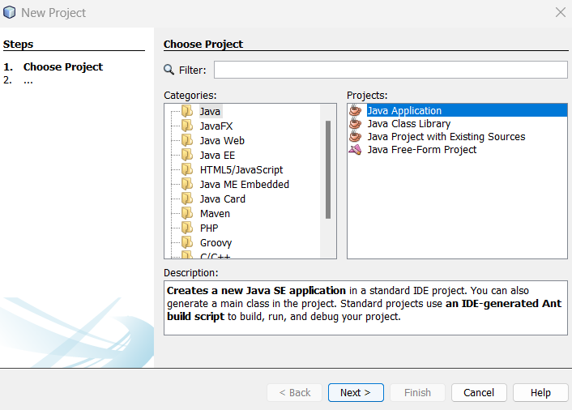

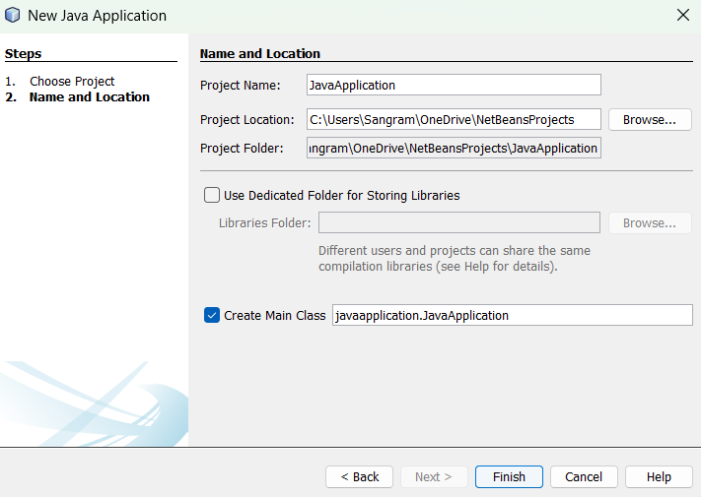

Step 14: In Java Application project, create a new web service client.

Right click on project 🡪 New 🡪 Web Service Client

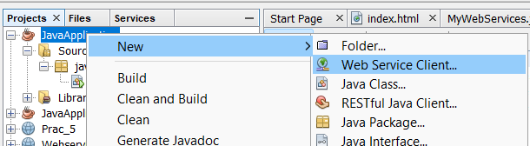

Step 15: In new web service client. Select wsdl URL. Paste the copied link.

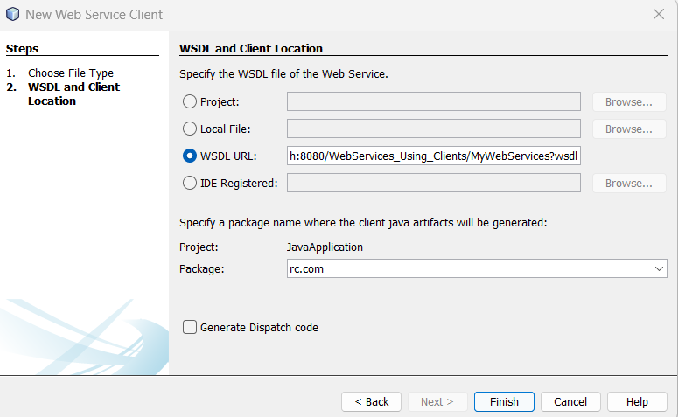

Step 16: Open JavaApplication.java. Type the following code.

MyWebService_Service service=new MyWebService_Service();

final MyWebService proxy=service.getMyWebServicePort();

System.out.println("Sangram Ghorpade 248624");

System.out.println(proxy.square(6.4));

Step 17: Now import the service packages.

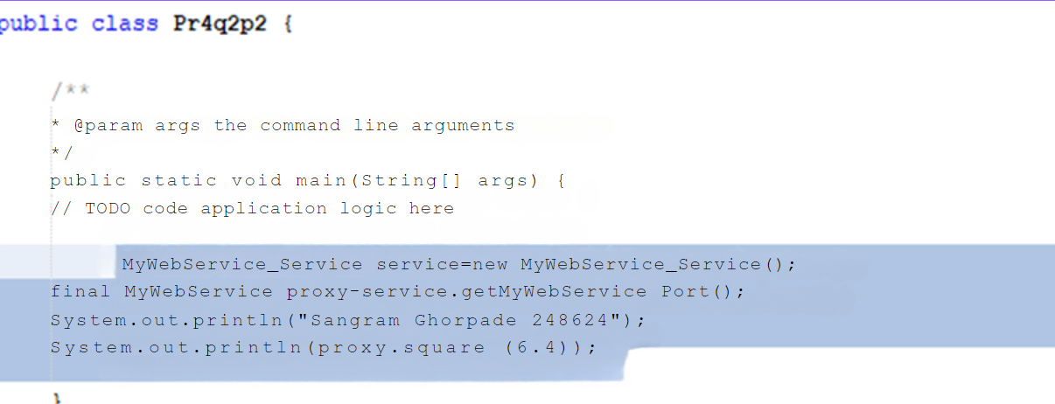

Step 18: Run the Java application project.

